**WEBSITE REPORT**

**Members**

|  |  |
| --- | --- |
| **Full Name** | **Registration Number** |
| **OTHINO MIKE BRANDON** | SCII/01365/2018 |
| **MIKE MYNE OTIENO** | SCII/02935P/2018 |

**Introduction**

Myne Royale Incorporation is an artillery shop; one of its kind in Kenya; that deals in gun purchases

acting both as a separate military detachment branch while at the same time compensating

for both local homeland security purposes and international as well.

Having first being initiated as government project to fester security locally back in 2013, the idea itself was sparked by two young individuals Mike Myne and Mike Brandon who saw a gap in the security and welfare of the society and thus proposed the revolutionary idea to the government that offered them funding. The business soon emerged successful, having curbed security issues by 20% over the years nationally, thus was recommended as an authentic and secure business both nationally and later on internationally as well.

The business offers a variety or arsenal ranging from powerful guns such as shotguns and barrel guns to simple mini guns like pistols and uzi's.

The Myne Royale Incorporation having been in business for the last 5 years has assured its customers legitimacy with its products

The business, being both national and international, is located locally at the following towns in Kenya:

1. Sanhok – Headquarters
2. Miramar
3. Pochinki behind PUBG academy
4. Lootlake
5. Erangle
6. Fortbite

Outside the country we have external branches in the following countries:

1. France
2. USA
3. Germany
4. Russia

Be informed the business offers dedicated delivery for online purchases but at a fee depending on the product and location. We welcome you to engage with us and appreciate your feedback.

***SELF DEFENSE IS NO OFFENCE!***

**WEBSITE DESIGN**

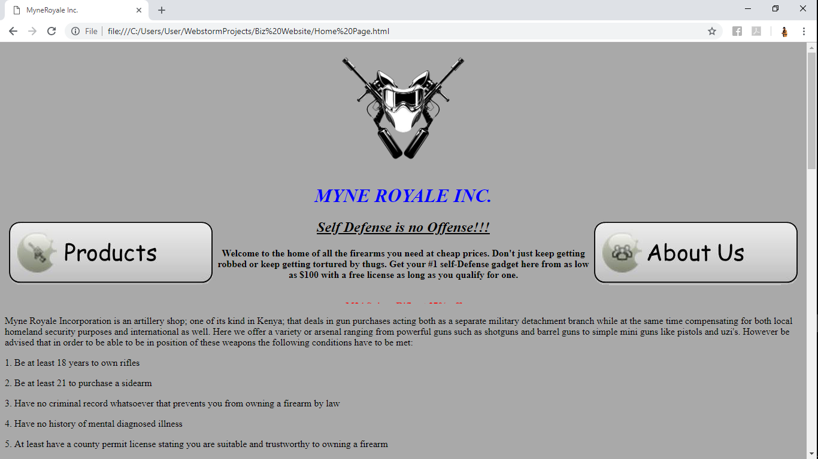

Figure HOMEPAGE

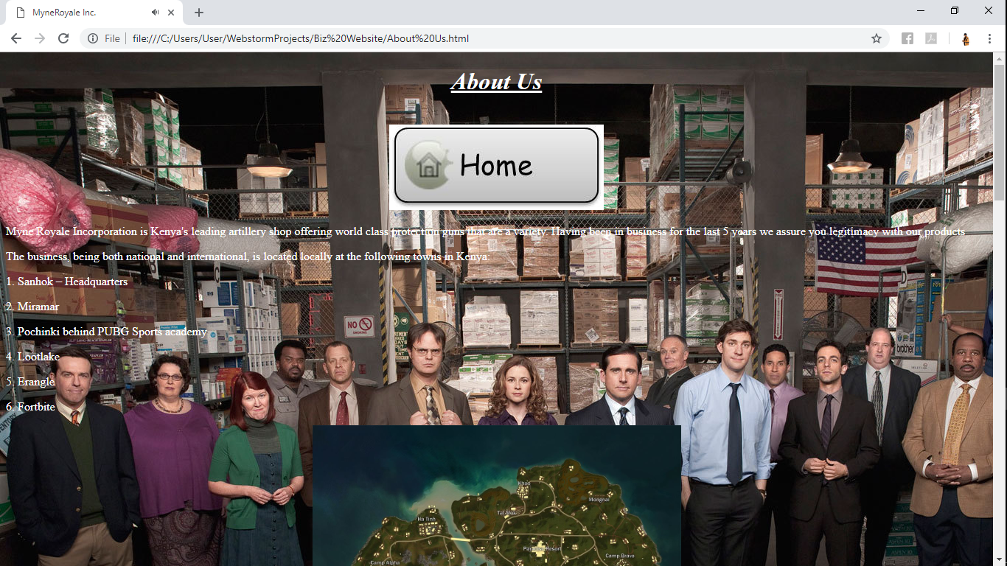

Figure ABOUT US

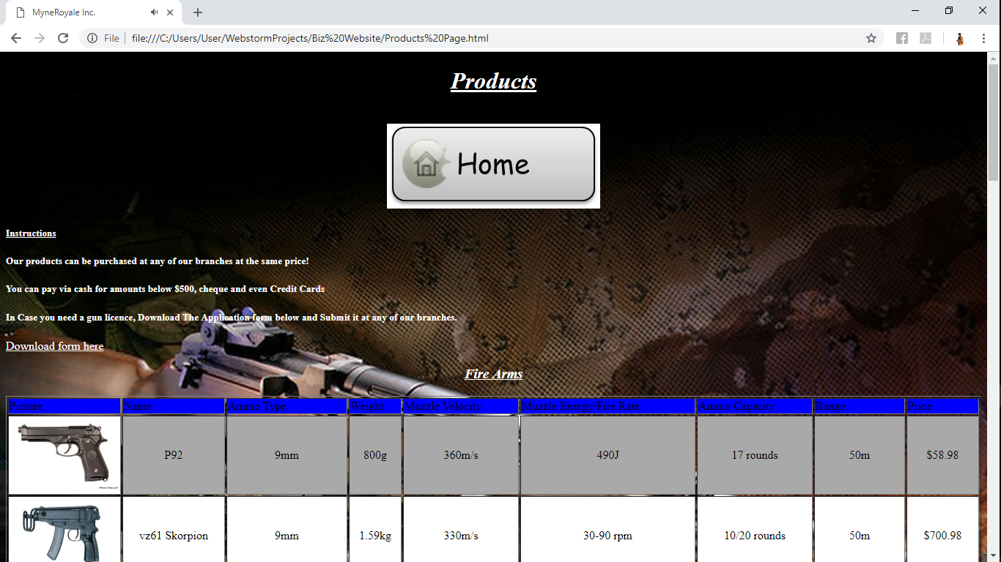

Figure PRODUCTS PAGE

The website was designed using HTML 5 and Webstorm Software for Web Development. No CSS and Javascript was used whatsoever.

**References**

[**www.w3schools.com**](http://www.w3schools.com)

[**www.wikipedia.com**](http://www.wikipedia.com)